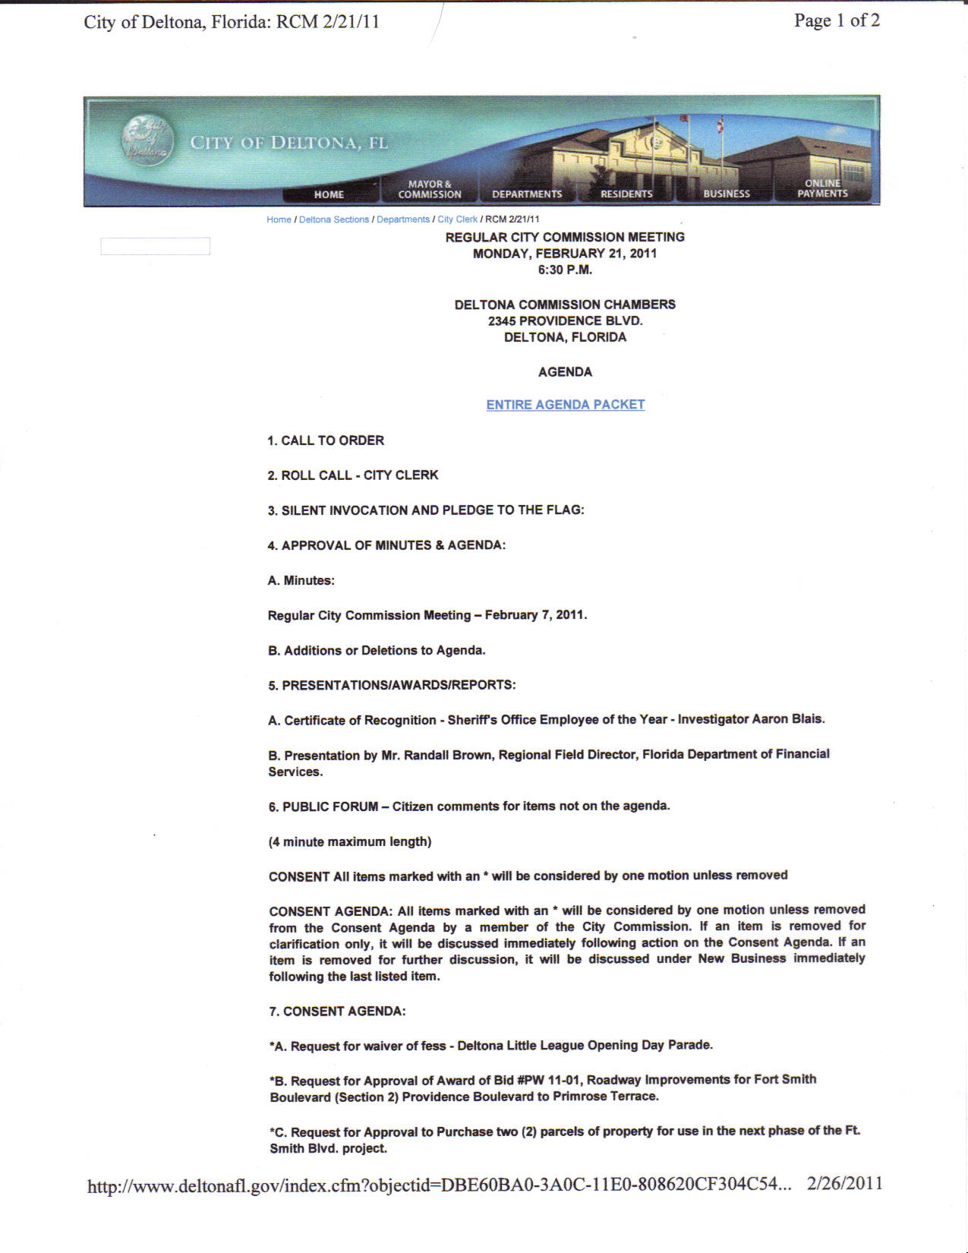

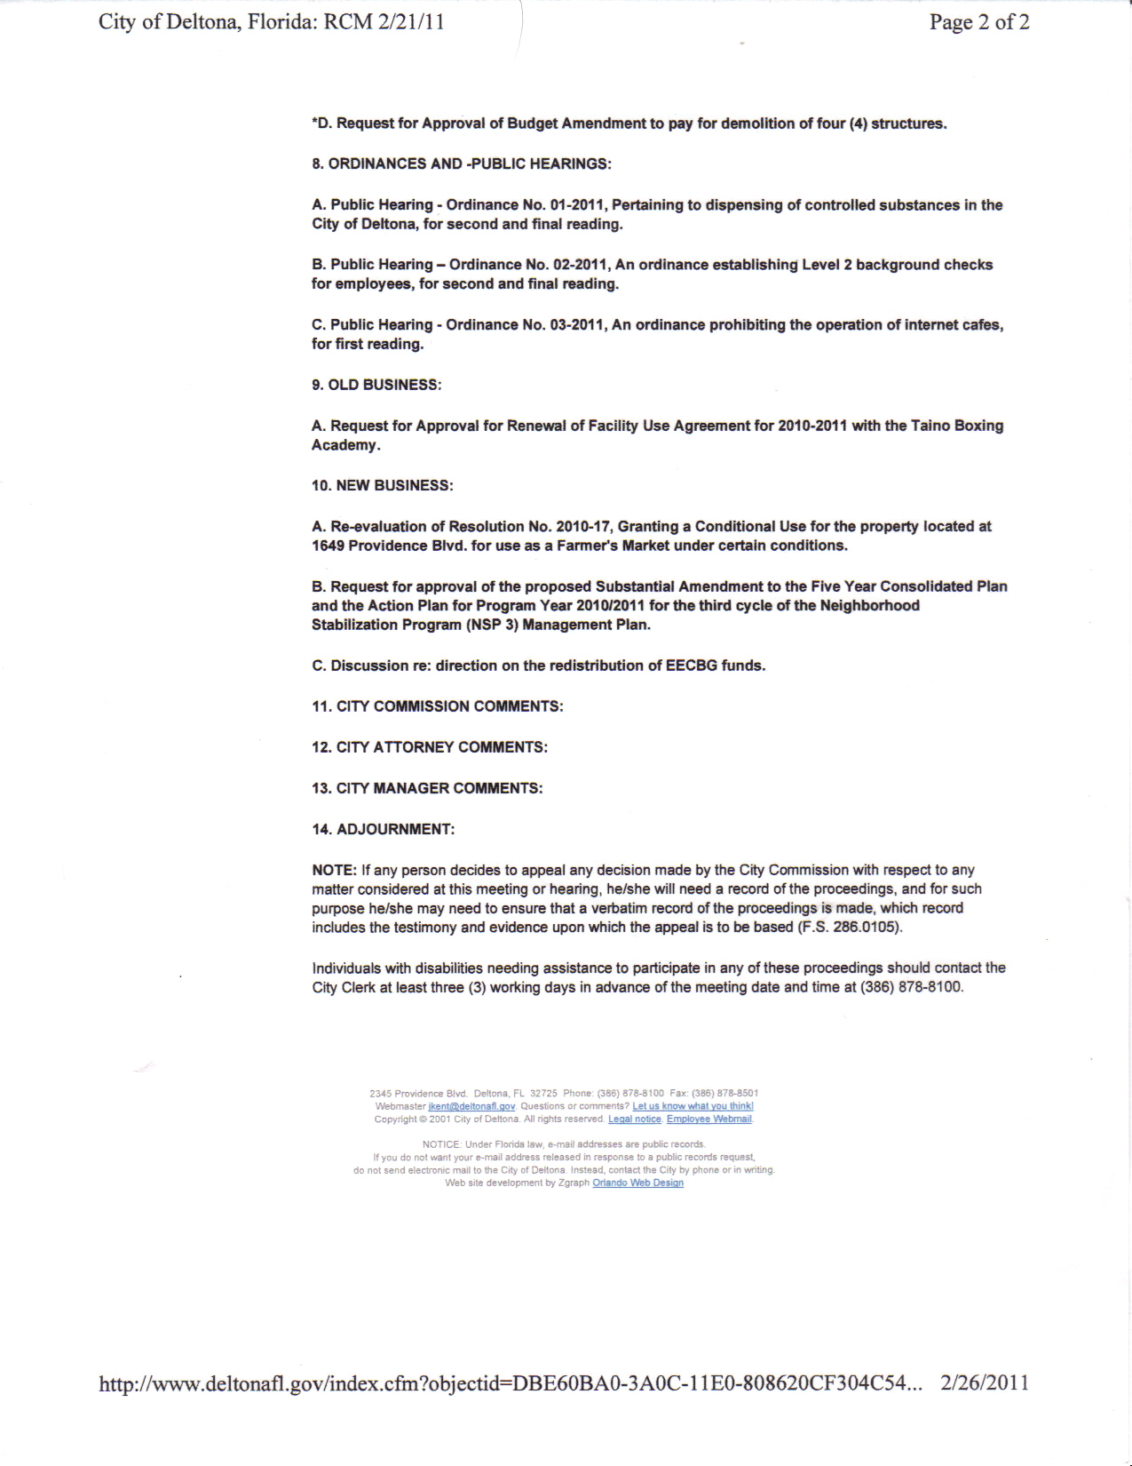

Eve Wittlin-Young
Government Meeting for Monday 2/21 Synopsis (Web Broadcasting)
Viewed 2/26
After viewing the City Commission Meeting via web broadcasting I can now see how these meetings are incredibly valuable to the community members. These meetings create awareness of the events and situations that are actively going on in the community and offer community members to become involved by speaking their opinions and ideas on particular items as well. However, I was quite surprised on the extensive length of this meeting, and due to the length and vast amount of material discussed and debated I will summarize the data I had found to be the most significant and that has the most impact on public health and overall health of the community.
During the early segment of this meeting a certificate of recognition was announced and awarded to an Investigator of Deltona who had successfully “taken down” a large cocaine operation and seized 1200 gm of cocaine and $9,000 of drug money. First of all, I could not believe that there was a drug/ cocaine act going on in my community, I find this incredibly important to discuss because having drugs, such as cocaine, in our community significantly affects our community member’s health and safety. For instance, many drug operations often produces an increase in crime and violence in the community and all community members must be aware of these operations that exist in order to contact correct officials when suspecting suspicious activity to promote health and safety to all community members. I also would not want my children near any sort of drug activity nor individuals on drugs. If we were to work together as a community to a promote drug free environment and no tolerance, all individual’s health would benefit. Also in the early segment there was a presentation completed on decreasing financial fraud and Medicare fraud that I had appreciated. I believe that if Medicare fraud was decreased and the money that is being “wasted” and spent illegally was stopped, there would be more funding available to the individuals who honestly need the money for actual services to improve and maintain their health, ultimately increasing the health of the public/ community members.
A major issue that seemed to be discussed at several points in the meeting, that I feel may have a significant impact on my community, was the topic of neighborhood stabilization program. To begin, there was a community member, Mike that had announced the great success they have had with this program, he had shared with the community a particular event that was held over a previous weekend with a large number of relators on site, open houses were provided and houses were being sold. At first I was unsure what this member was speaking about, until later on in the meeting a third cycle of Neighborhood Stabilization Program was discussed in depth. It was announced that the city is eligible to receive $1,965,066. 23 for this program, where basically vacant homes are bought in the community then fixed in it’s entirely and sold on the market. I thought this program would be wonderful to promote health to the community because I always view vacant homes as a safety hazard in the community, whether it be a fire hazard, a drowning hazard if the vacant house had a pool, a health hazard and not to mention the fact that many homeless or troubled individuals will take over vacant homes and it becomes an area for crime, such as rape, to occur so to remove as many vacant homes from the community is ideal. I was disappointed to hear, though, the debate over this issue. There were a few members present that had felt the program was useless and that the homes would not get sold. Members were confident to say that foreclosure homes will sell first, as they are more affordable in the market. There was even a member that had said to send the money back to the federal government, I honestly could not believe it, here the city can take the million dollars, remove the hazards of vacant homes, and provide jobs/ work when contracting and repairing these homes (stimulating our economy) to better our community and they are questioning whether to send the money back, I was shocked.
During this meeting there were many other topics discussed such as the distribution of EECBG funds and spending the funds on solar panels for signals and pedestrian signs, many community members voiced their opinions on the outrageous million dollar budget for repairing Ft. Smith, the requirement of level 2 background checks and the differences between level one and level two, and creating a farmer’s market in the community. A few other topics that were debated in detail that I would like to share include stopping the operation of internet cafes, removing pain clinics and preventing dispensing where drugs are prescribed, and providing a boxing gym for community members. I do agree with discontinuing the use of internet cafes, personally my brother had owned and operated an internet café in Ocala (it was closed down) and I had once visited him and was disappointed to see the population that he was serving. Many of the customers I had discovered were unemployed and were actually using their unemployment or other types of government assistance money, to gamble which I found to be unacceptable; also, he was once robbed so I do believe that this type of business has the possibility of increasing the crime in a community. Luckily there was not much debate over the discontinuing of these sweepstakes. It was also discussed that pain clinics should not be able to operate and a practitioner should not be able to prescribe controlled substances where they are dispensed. There was much discussion on the statistical data of opiates that was presented during this meeting, the statistical data being stated included that out of all of the oxycontin prescribed in the United States, 85% of oxycontin pills are dispersed in Florida and that 41.2 million doses of oxycodone were prescribed from Florida Healthcare practitioners in just six months. There was no debate over these issues, all individuals agreed that these medications should not be so easily obtained in order to protect the health of community members and decrease the number of individuals that overdose from these medications. Lastly, a major issue that was debated intensely was the approval for renewal of the facility use for a boxing academy. There were community members that had spoken openly for the need of this boxing academy in Deltona, some had stated that this is a sport that creates brotherhood among members and keeps kids out of the street and into positive and purposeful acts. There were even community members that had shared their personal stories of how this sport has helped their child perform better in school. Then there were community members that were completely against this sporting activity, discussing the injury risk and brain damage that may occur with this violent sport. The risks of lawsuits were also discussed heavily. For instance, when an individual is severely injured the city may possibly be liable for this injury as it was in their facility. Personally, as a mother and a nurse, I could not imagine why anyone would want to become involved in such a dangerous “sport”. I honestly do not understand the purpose of this so called sport, where the goal is to actually attack your opponent and “knock out” the other human being that is standing in front of you. I see boxing as a very crude sport that has the potential of increasing violence in individuals and possibly in the community. Overall, I found this city meeting to be beneficial as a community member, I had discovered multiple issues that are currently going on in my community that I had no idea even existed. I definitely look forward to viewing further meetings to gain knowledge of the events that are happening in the community.

